|  |  |
| --- | --- |
|  | **2017** |
|  | Challenger Institute of Technology  South Metropolitan TAFE  Fremantle |

|  |  |
| --- | --- |
| **[Progress report]** | |
|  |

Table of Contents:

* Introduction
* Evidence
* Conclusion

Introduction:

The objective of the Progress report is to inform and update all our lecturers on how the lathe project is going as well as, assist in making people on the amount of work they have done toward the project.

The main objective for this semester was to convert the purely manually lathe into a CNC (computer numerical control) lathe, that is going from a human moving everything except the spindle to having a computer do all the work.

Evidence:

This page is to show all evidence that I have done in the second term of the first semester. This will include my CAD (computer aided design) work as well as my contributions to helping set up the moving model. These will be shown with pictures and have a small sentence to explain the picture and what is being done.

**Picture 1:**­­­­­­­

The Encoder body is part of the encoder assembly.

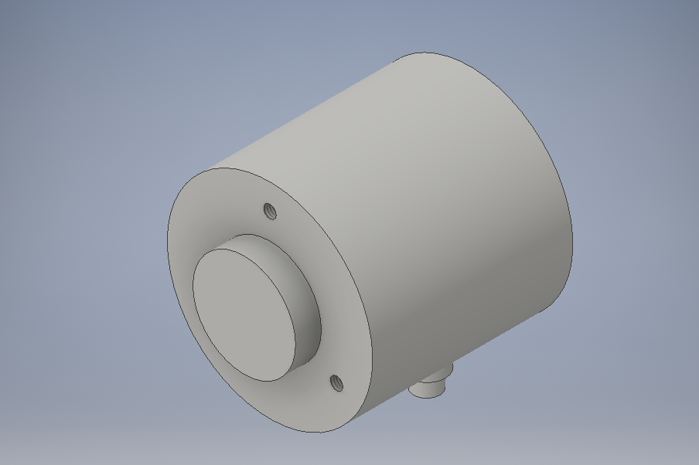

The Encoder shaft this is the second part of the encoder assembly.

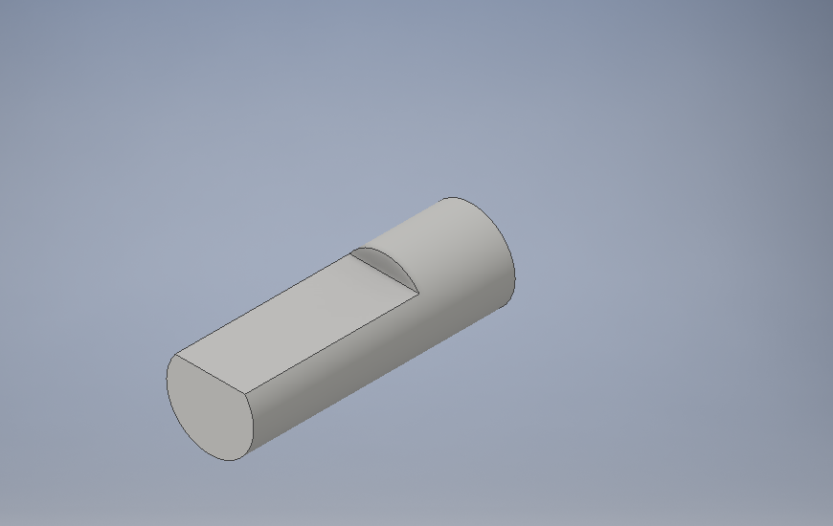

Working encoder model.

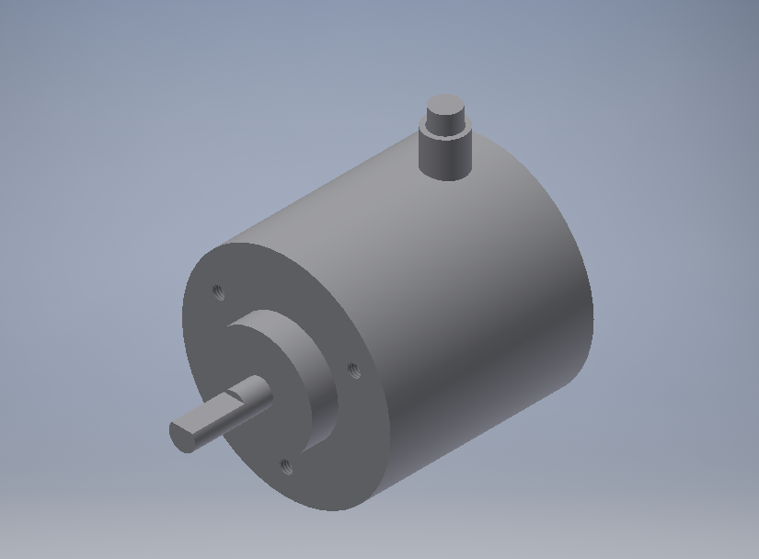

Servo Motor Body used for the serve motor.

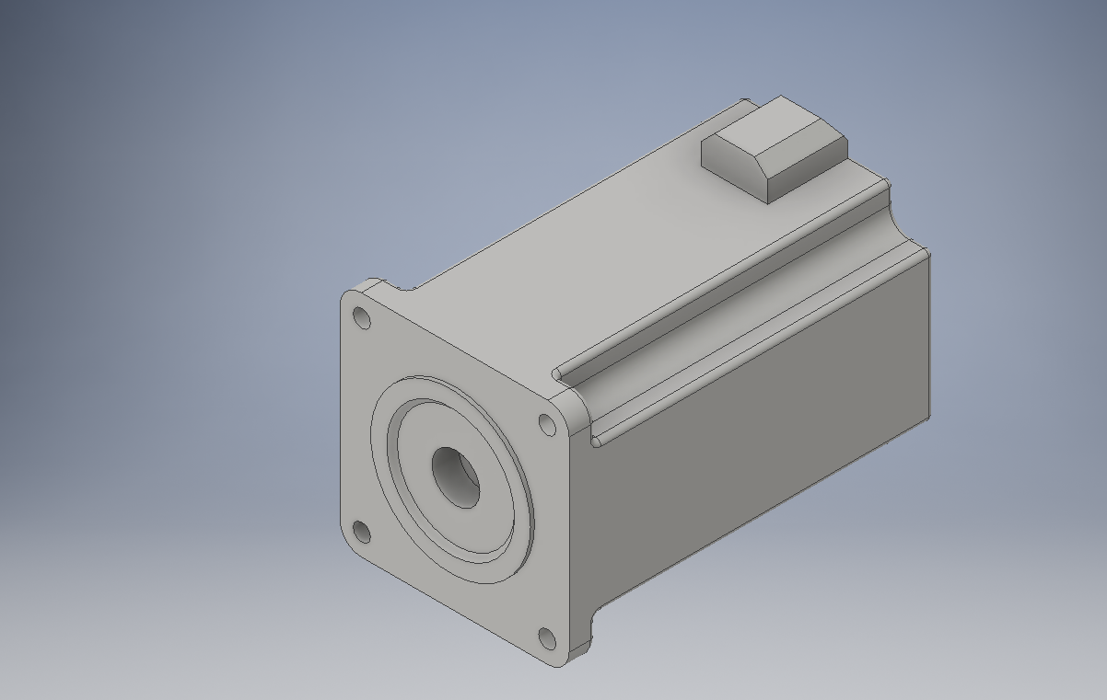

Servo Motor Shaft second part to the servo motor.

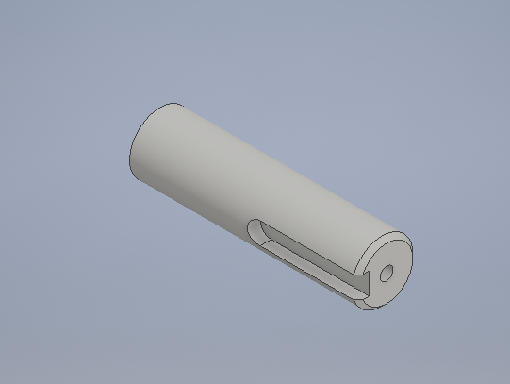

Working servo motor assembly.

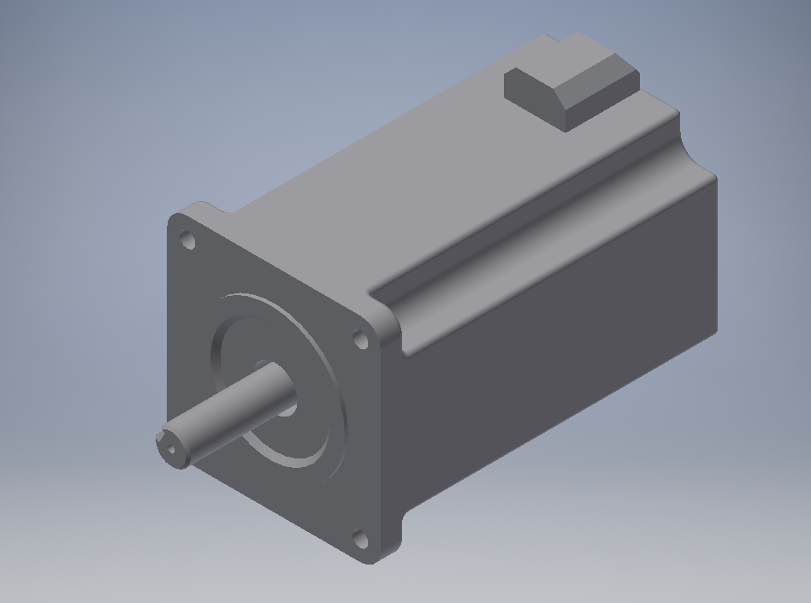

Shaft that translates the electric motor rotation though a belt and connects it to the gear box and out to the chuck.

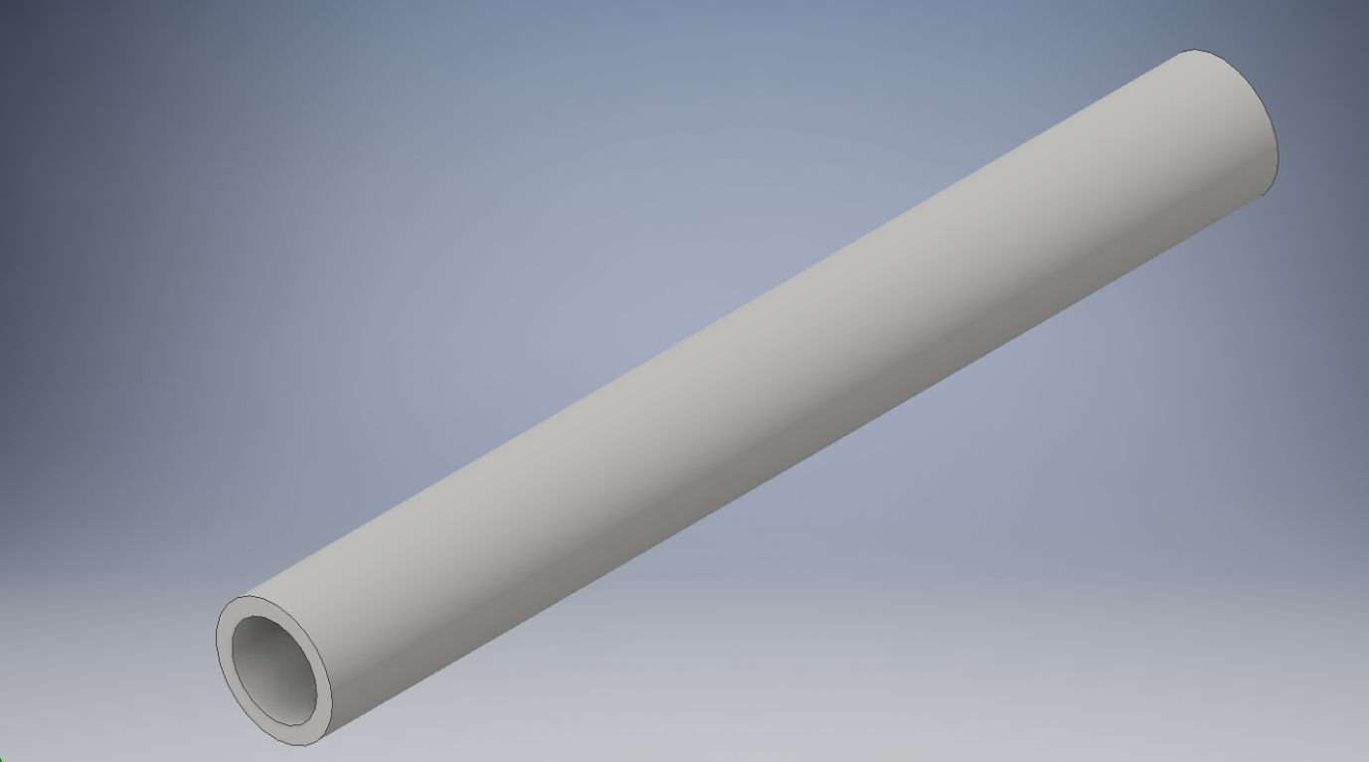

Gear Box disassembly was done by myself and Alex

Before: After:

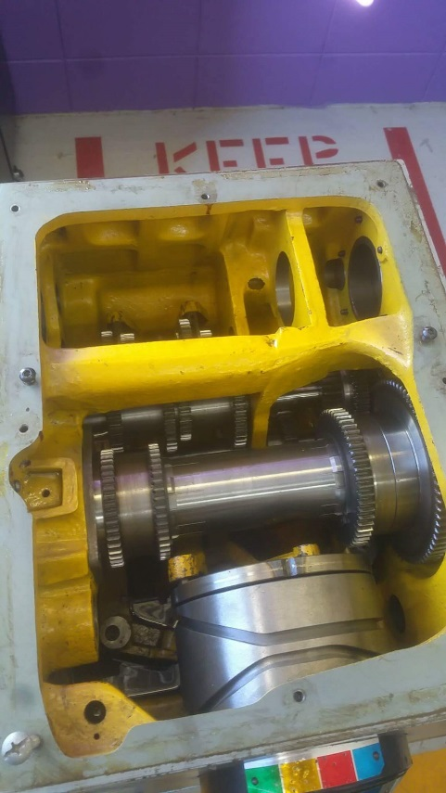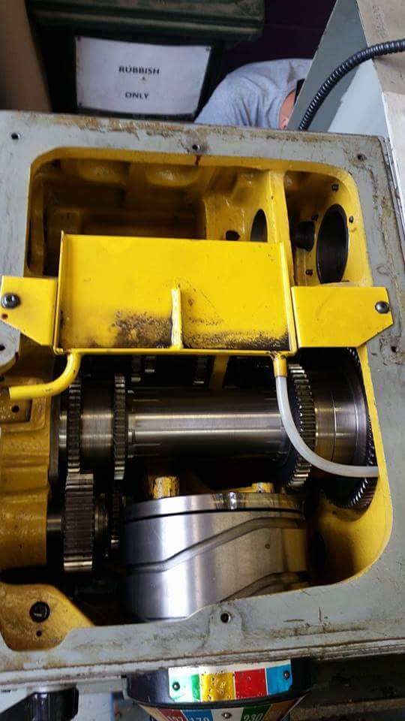

The full CAD was done by everyone I have helped by adding some limits to allow parts to move in out cad to show different points in the CAD.

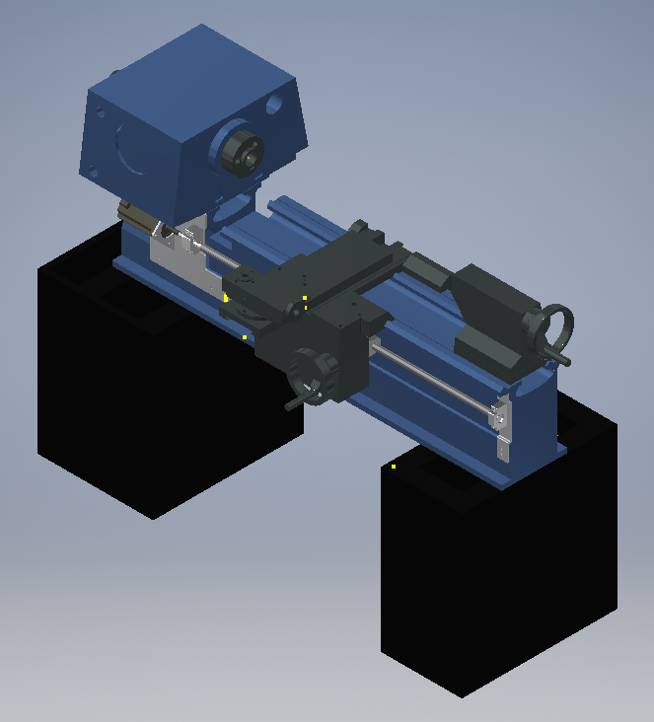

**Conclusion:**

To sum up I have provided different CAD models to the group as well as help get the moving lathe to show how it works but also allow a more accurate drawing. I have also help lead the electrical team with research and filling in documents.